Data Operations - Validation

Definition
# Source: AI Source: Provided by: [Data Path: Persons Table -> ID Column: 1, Name_En Column: Motasem Essam] -> From: [Chatgpt (GPT‑5 Mini)] on [12/10/2025]
Validation is the process of checking data for accuracy, consistency, and correctness before it is stored, processed, or analyzed.
- Ensures that data meets predefined rules or standards.
- Helps prevent errors, inconsistencies, and unreliable results.

Key idea:
# Source: AI Source: Provided by: [Data Path: Persons Table -> ID Column: 1, Name_En Column: Motasem Essam] -> From: [Chatgpt (GPT‑5 Mini)] on [12/10/2025]
It’s like proofreading a document to make sure all information is correct and complete before publishing it.

Characteristics of Validation
# Source: AI Source: Provided by: [Data Path: Persons Table -> ID Column: 1, Name_En Column: Motasem Essam] -> From: [Chatgpt (GPT‑5 Mini)] on [12/10/2025]
- Ensures data accuracy and integrity
- Can be applied to format, type, range, uniqueness, and completeness
- Often performed during data entry, import, or transformation
- Helps catch errors early before they propagate into analysis
- Can be manual (checking records) or automated (software rules)

Validation Rules
# Source: AI Source: Provided by: [Data Path: Persons Table -> ID Column: 1, Name_En Column: Motasem Essam] -> From: [Chatgpt (GPT‑5 Mini)] on [12/10/2025]
Definition
Validation rules are conditions or checks applied to data to ensure it is correct, accurate, and valid before it is stored or processed.
Key idea:
They help prevent invalid or incorrect data from entering a system.
How Validation Rules Work
- Data is entered by a user or system
- Validation rules check the data against predefined conditions
- If the data is valid → it is accepted and saved
- If the data is invalid → it is rejected or an error message is shown

Types of Validation Checks
# Source: AI Source: Provided by: [Data Path: Persons Table -> ID Column: 1, Name_En Column: Motasem Essam] -> From: [Chatgpt (GPT‑5 Mini)] on [12/10/2025]
- Format Check – Ensures data follows the correct format
  - Example: Phone numbers must be 10 digits, emails must contain “@”
- Range Check – Ensures numeric data falls within allowed limits
  - Example: Age must be between 0 and 120
- Consistency / Cross-Field Check – Ensures data is logically consistent across records
  - Example: End date cannot be before start date
- Uniqueness Check – Ensures no duplicate entries exist where uniqueness is required
  - Example: Employee ID must be unique
- Mandatory Field Check – Ensures required fields are not empty
  - Example: Name, Email, or ID must be filled
- Referential / Lookup Check – Ensures data matches a value from another table or a predefined list
  - Example: Employee table’s Department ID must exist in the Departments table

Examples
# Source: AI Source: Provided by: [Data Path: Persons Table -> ID Column: 1, Name_En Column: Motasem Essam] -> From: [Chatgpt (GPT‑5 Mini)] on [12/10/2025]
- Student Database:
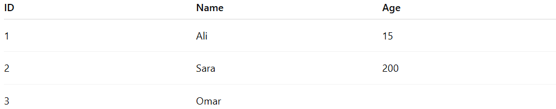
ID | Name | Age
1 | Ali | 15
2 | Sara | 200
3 | Omar
- E-commerce Registration:
- Email: user@example.com ✅
- Email: userexample.com ❌ ← fails format check

Advantages
# Source: AI Source: Provided by: [Data Path: Persons Table -> ID Column: 1, Name_En Column: Motasem Essam] -> From: [Chatgpt (GPT‑5 Mini)] on [12/10/2025]
- Ensures high-quality and reliable data
- Prevents errors in analysis, reporting, and decision-making
- Saves time by catching mistakes early
- Supports data consistency across systems

Disadvantages
# Source: AI Source: Provided by: [Data Path: Persons Table -> ID Column: 1, Name_En Column: Motasem Essam] -> From: [Chatgpt (GPT‑5 Mini)] on [12/10/2025]
- Can be time-consuming for large datasets
- Requires predefined rules which may not cover all cases
- Automated validation may miss complex logical errors
- Overly strict validation can reject legitimate data

Example Section
# Source: AI Source: Provided by: [Data Path: Persons Table -> ID Column: 1, Name_En Column: Motasem Essam] -> From: [Chatgpt (GPT‑5 Mini)] on [12/10/2025]
A company collects employee data and validates it before storage:
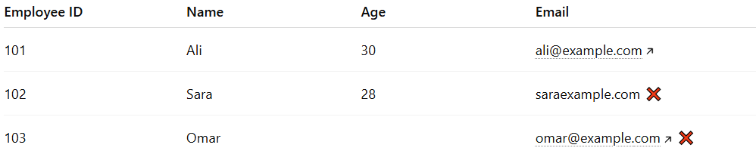
Employee ID | Name | Age |  | Email
101 | Ali | 30 |  | ali@example.com
102 | Sara | 28 |  | saraexample.com ❌
103 | Omar |  |  | omar@example.com ❌
- Validation identifies Sara’s email format error and Omar’s missing age.
- Only correct records are saved, preventing future errors in payroll or reporting.

